Tab 1

Sriram CORRECTIONS

Nav bar

Remove download brochure here in hero section and move it to the individual programs…inside program section
Nav bar

Register Now, pop up box is to basic boring
APEX Community
In Apex, there is no place for the new joiners to enter, only we can login
Hero Section
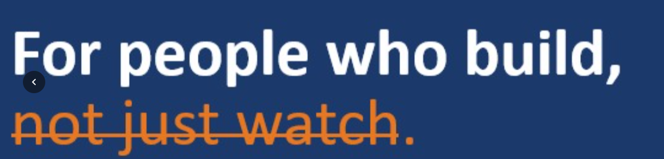
2nd page

Remove the text “Application form”
2nd page

Remove the “download brochure” button
2nd page

Fill (first letter upper case), {keep ai and journey together}, AI (upper case)
3rd page
The lines below what is onrol?.....arrange then 2 lines!!
Remove the complete to the bullet points {looks repetitive}
The execution model…should…has separate….animation…like a arrow from learn to build to monetize…….{should be the highlight of the page}
Remove the text “EDITORIAL QUOTE” and keep it in italics and the bottom as a quote.
Why does this matter now?
Should be existed as the individual page
To create fomo and to establish the why ai is important
The quote of “AI won’t replace you” at the latter page should come here
The line under why do we do it also should come here
3 rd page
What do we do?
Same, the lines should extend till the end
The next 3 things, should be added with infographics
5th page
Programs built for real execution
No need of the 3 boxes at the top, remove them and just add AI generalist program./
Remove the view details at the bottom of the product.
6th page
Enhance the green and red colour
The quote at the bottom can be moved to middle, with the different icon before it
Learning does not end after the session
Remove the learn, build and monetize and replace it with the community momentum (box from the right)
Now on the left make it clear to join the apex community
Can remove the register now from here!!
Explore the option of bringing this to the top section.
Corrections From Hasini

CORRECTION from Akbar

There are white colored sections in the website that need to be recolored to match the overall theme of the website.
Testimonials don't have any names. And Testimonials need to have real Human Picture.
I think the website should align with our webinar landing pages. Like outskill
There is no curriculum breakdown in the front page.
We already have the curriculum breakdowns in the programs section, just need to add one section to the front page.
There is no QNA -

QNA will be made after the Insights are over and the front page is ready.
Our website overall doesn't look professional and premium, compared to outskill or scaler. - Design.

Corrections from Ravindra
Nav-bar apex community visibility
Ready to Build Your Future?
Learn → Build → Launch → Earn

Hero page
- Bold headline
- Subheading with value proposition
- AI chatbot showcase
- Brochure update (keep it top of webpage)
- bwfm animation
Brand intro
- font
- more paragraphs reduce
- use cards
- side border
Learn →build→launch→earn
What do we do
- use icons (customer,workflow,website)
- tools (check redirections)
- reduce the space in auto scrolling

Apex community from nav bar is not visible in white them
Community & Collaboration Section
-Open visuals/images
-Showcase collaboration
- Partner with Onrol
- Add basic animations
- Add engaging text
- Improve community visibility
Chatbot
- Existing chatbot feels inconsistent/messed up
- Redesign chatbot UI
- Add floating chatbot widget
- Improve chatbot interaction design
- Better spacing and responsiveness

Contact Section
- Add separate popup redirection
- Redirect users to next page after actions
- Improve conversion flow

CTA Goals
- Book a 15-minute call
- Register for programs
- Join free masterclass
- Download brochure

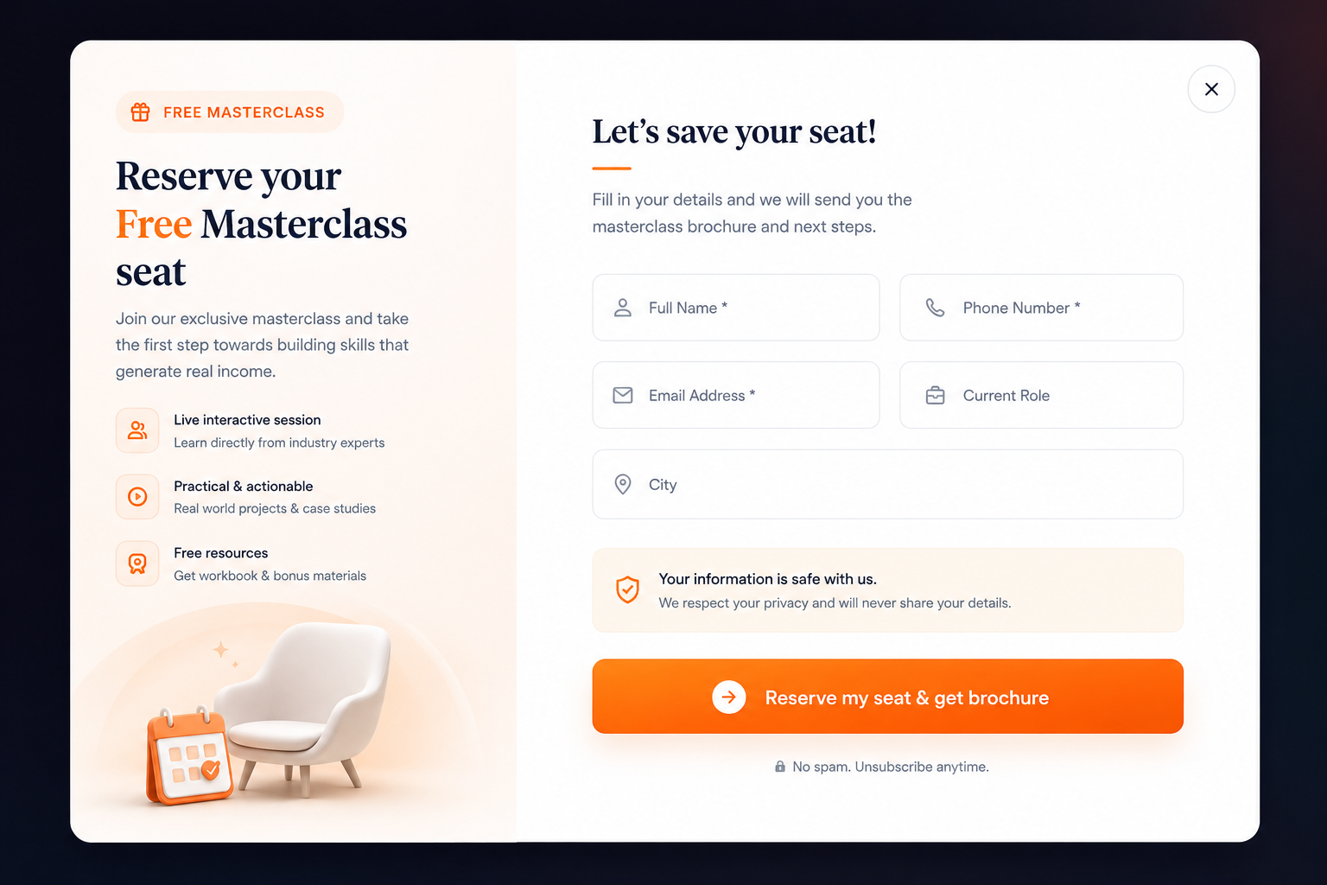 | Master class ui design
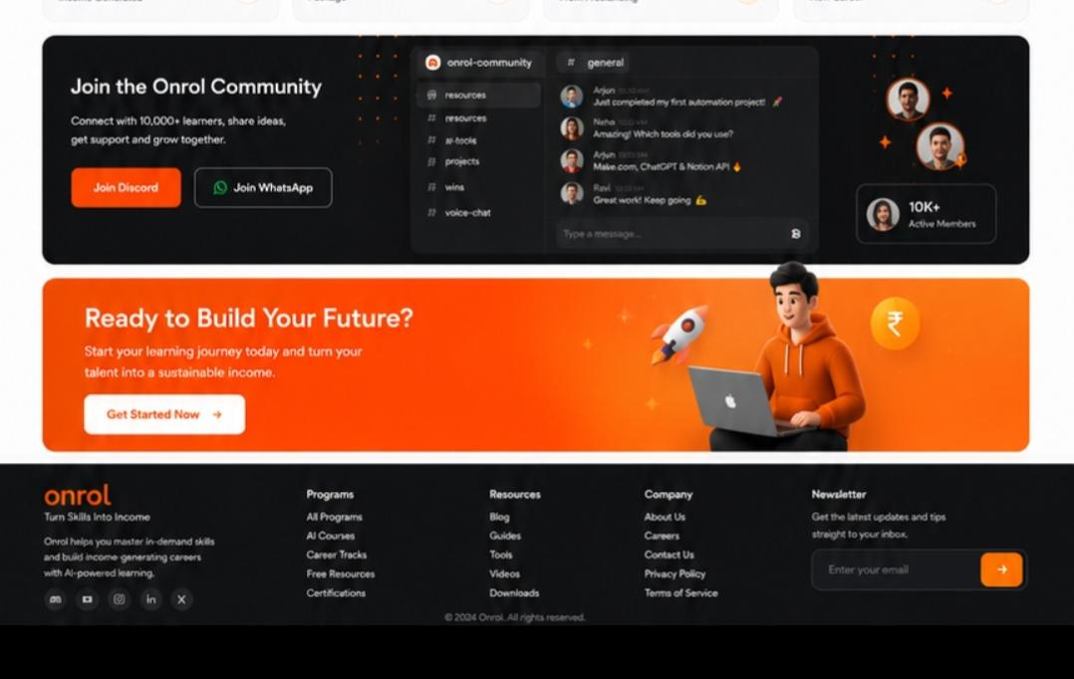 | Footer

Akbar
CORRECTIONs from Akbar

Stop consuming AI.
Start building with it.
From scrolling AI tutorials to shipping your first AI product — in under a week.
We bridge the gap between AI experimentation and actual career outcomes through intensive bootcamps, advanced tracks, hands-on mentorship, and execution-first learning.

Begin with Free Masterclass (Button - AI agents / Vibe coding webinar)

100+  BUILDERS TRAINED | 3  LIVE PROJECTS PER LEARNER | 5 days  ZERO TO FIRST LAUNCH

